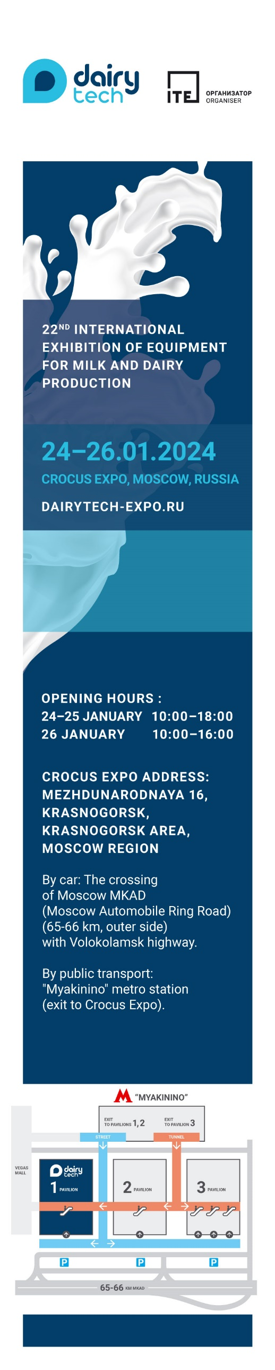

SAVE THE DATE

Dear colleagues and partners!
Our company _________________ invites you to meet us at stand №________ at the 22nd International exhibition of equipment for milk and dairy production DairyTech 2024!
The exhibition will be held January 24-26 in Russia, Moscow, at Crocus Expo, Pavilion 1, Hall 4.
DairyTech – is the first exhibition in Russia where is the only international exhibition in Russia encompassing the full range of equipment for milk processing and dairy production.
Our company will take part in the exhibition for the ___ time.
Get your free ticket>> using a unique promocode PROMOCODE that needs to be indicated when registering, and you will be able to see our products alive at our booth:

- Please indicate here what kind of products will be showcased at your booth.

Looking forward to meeting you at our booth №_______!

Please find full range of products at our website: _________________
Contact details: __________________________________________________

